**Java to C Compiler Project**

**“CoopJa"**

**Group:**

**Nicholas Araklisianos**

**Miguel Cruz**

**Jacob Poersch**

**Carlos Sandoval**

**SPRING 2019 - May 16, 2019**

**COMP 430 – Language Design and Compilers**

**TABLE OF CONTENTS**

Cover Page ….…………………………………..…………………………………………..1

Table of Contents………………………………………………………………..……….....2

**Section 1. The Goal of the Project**………………….....…...………………..…….…...3

Project Overview…………………………….………...............................................……3

Definitions, Acronyms, and Abbreviations…………………………………...……….......4

General Constraints…………………….……………………………………………….......4

Non-Trivial Features…………………………………………………………………………4

**Section 2. Language Specifications & Features (Syntax)** ……….…….……..…...5

**Section 3. Implementation Order & Descriptions …..**…….……...……….…….…..7

Retrospective….......………………………………………………………………..…….…9

**Section 4. Tokenizer** ………………………………..…..……………..…...……….…...10

Files Pertaining to the Tokenizer…………………………………………….….….…….10

Other Files ….……….......………………………………………………....………………10

Reserved Words / Symbols….……………………….…………………………………...11

Variable Naming Restrictions……….......…………………………...……………………13

Tokenizer Output……….......…………………………………….…...……………………13

**Section 5. Parser** ………………………………..…..……………..…...……….………..16

**Section 6. Type Checker** ……………………..…..……………..…...……….…………24

**Section 7. Code Generator** ………………………………..…..…….……….………....25

# 

# Section 1. The Goal of the Project

## Project Overview

The goal of our project is to create our own programming language based on the existing programming language “Java.” Then, we will use this made-up language as input and create a Compiler that will translate the given program into valid C code.

Since we all are most familiar with the Java programming language, and our made-up language is based on Java, we decided to make this our Implementation Language. After some discussion between the group members, we decided we could add some things that would be meaningful to the C programming language. We were also all interested in working with this language as well, so we made C our Target Language.

The name of our compiler “CoopJa” means and comes from the abbreviation: “C’s Cooperative Object Oriented Programming from Java.” This is because we plan bring Java’s Object Oriented Programming nature to C with our compiler. Since Java supports OOP and C does not, our compiler will bridge the gap and implement this feature in C.

## Definitions, Acronyms, and Abbreviations

This section outlines all definitions, acronyms, and abbreviations that may not be known to some / all of the readers of this documentation. These terms all pertain to our project specifically or relate to general terms we may use.

|  |  |
| --- | --- |
| **Term/Acronym** | **Definition** |
| **Implementation Language** | **The programming language our Compiler is written in. In our case: Java** |
| **Target Language** | **The language our Compiler will compile to / its output. In our case: C** |
| **OOP** | **Object Oriented Programming** |
| **“CoopJa”** | **The name of our compiler. It stands for: C’s Cooperative Object Oriented Programming from Java** |

## General Constraints

Due to the limited time of the semester, it is necessary to restrict our made-up language to have fewer features than the full Implementation Language. We will not be featuring any memory de-allocation, nor any garbage collection. We also will not be featuring any Generics in our language.

## Non-Trivial Features

1. Our first non-trivial features is type inference using the keyword / type “auto”. This is covered in the TypeChecker section.
2. Access modifiers are our second type non-trivial feature. We have public, private, and protected. More about this is in the TypeChecker section.
3. Class-based inheritance is in our language. More of this is in the Code Generation section.

# Section 2. Language Specifications & Features (Syntax)

The following is our made-up language’s syntax:

*var* is a variable

*objectname* is the name of a class

*methodname* is the name of a method

*str* is a string

*i* is an integer

type ::= int | double | char | boolean | string | auto | [Built in types of variables]

objectname [Objects are also types]

op ::= + | - | * | / | [Arithmetic operations]

> | < | >= | <= | == | != | ==| | [Comparison Operations]

| | & | ^ | >> | << | ~ [Bitwise Operators]

var++; | [Increments a variable]

var--; | [Decrements a variable]

vardec ::= type var [Variable declarations]

exp ::= var | str | i | [Basic expressions]

Exp op exp| [Arithmetic expression]

println(exp)| [prints to the terminal]

This [Refers to this instance]

objectname.methodname(Var*) [Call Method]

new objectName(exp*) [Declare a new instance of an object]

access ::= Public | Private | Protected [access type for a method or var]  
stmt ::= vardec; | [Variable Declarations]

var = exp; | [assignment to variable]

If (exp) stmt else stmt | [standard if/else statement]

while (exp) stmt | [loop statement with restriction]

for (vardec; exp; exp) stmt | [for loop statement]

break; | [escape loop statement]

{stmt*} [block]

return exp| [return an expression]

return; | [Empty return]

instancedec ::= access vardec;

result_type ::= type | void [Return types]

methodef::= Access result_type methodname (vardec) stmt [Method declarations]

objectdefheader ::= access class objectname | access class objectname extends objectname

objectdef::= objectdefheader {

vardec* [Variable declarations]

public objectname {smt*} [Constructor]

methodef*

}

program ::= objectdef* exp [exp is an entry point]

program ::= objectdef* [The program itself]

# Section 3. Implementation Order & Descriptions

This section details the order in which we implemented each portion of our compiler and some details about why this is the case. Each specific part of the compiler will be further discussed in its own section later in the document. Note that the technical aspects of our code and implementation are outlined in these later sections.

The first step in the creation of our compiler was working on the Tokenizer / Lexer. The purpose of the Tokenizer is to go through our input program and find recognized keywords and terms in a “reserved words” list. For example, in order to have classes in our program, we must reserve the word “class” to create a class. The reserved words list includes the types of variables (like int, string, boolean, etc.), access modifiers (like public & private), symbol names (like equals, less than, slash, etc.) and other general reserved words (like void, null, true, etc.). A complete list of our reserved words will be in the Tokenizer section of the documentation.

The Tokenizer then identifies those reserved words and replaces those words with a Token object corresponding to that word. However, this list is impossible to be exhaustive, since a user can create a variable object with any name, within the restrictions of our language. For this, when the Tokenizer finds a word that it does not recognize, it classifies this as an “Identifier,” or the name of a variable, class, or method. The Tokenizer translates the entire input program into Tokens. This way, our compiler will be able to read and manipulate the given program to create meaningful output.  
 The next step in the process of writing our compiler was to write the Parser. The Parser takes the output from the Tokenizer and is able to decipher what is being asked from the original program and whether it is valid or not. For example, when declaring an “if” statement, the “if” keyword must immediately be followed by a left parenthesis, then an expression that resolves to a Boolean, than a right parenthesis and braces (Java & our language specific). If someone did not have the left parenthesis, the statement declaration would not be valid. The Parser uses the Tokens to determine if all that needs to be there in a declaration is in fact there. So the Parser will see an “if” token, and if it does not see a left parenthesis token immediately, it will call the statement invalid. However, the Parser is not able to tell if the statement within the parentheses actually resolves to a Boolean or not. This is because the Parser only cares about syntactic validity, and not content. The Parser is able to detect all that is defined within our language and checks the entire given program. When the Parser detects a proper-form “if” statement (for example), it puts this “if” statement into an object for ease of access later down the line. The Parser is able to define things such as variable declarations, method declarations, class declarations, and general statements. If the Parser passes, we can assume the program is syntactically valid.

After the Parser has checked the input program, the Typechecker will begin its check. The Typechecker’s job is to check the things the Parser does not. The Typechecker checked declared variables and makes sure they are not declared again or used incorrectly. For example, if the user declares an int variable but then tries to assign a string to it, this action would be caught as invalid by the Typechecker. The Typechecker would also be able to resolve the expression within an “if” statement (as mentioned previously), since it is keeping track of the names of all variables. This is to say the Typechecker is able to check the logic of the code. If there is no error in the Typechecker, the input program is valid.

The last step in the process of our compiler is the Code Generation. For this portion, we add some code to each object that the Parser creates. This code will be used to transform the given statement into C code. Code Generation is the process of checking each object, since we have determined that they are valid syntactically and logically, and outputting its C code. Once the entire program has been transferred to C code, our compiler can also output this program to a .c file and run it through a C compiler and check the output. This is used in testing to see if the expected output matches the actual output of the program we inputted.

## Retrospective

Looking back on our project, our group is very pleased with the results. It is amazing to see the project come together, from learning what exactly a compiler does, and what each component entails, to actually building those components. It was a very interesting process through which we learned a lot.

**Section 4.** **Tokenizer**

## Files Pertaining to the Tokenizer

* Token.java – The whole Tokenizer file is stored here, including a list of reserved words the Tokenizer uses.
* test\TokenizerUnitTests.java – The Tokenizer Unit Tests. Note “test\” refers to the fact that this file is not in the normal directory of .java files, and is in the test directory since it contains unit tests.

## Other Files

* TokenizerExampleTest.java – This file explains the usage of the Tokenizer and gives some examples of it being used. This file could also be considered the Main() method for the Token file, since Token.java does not have one.

## Reserved Words / Symbols

Our Tokenizer checks to see if the input program, word by word, is one of the listed reserved words. Complete list of reserved words here:

|  |  |  |  |  |  |  |  |  |  |  |  |  |  |  |  |  |  |  |  |  |  |  |  |  |  |  |  |  |  |  |  |  |  |  |  |  |  |  |  |  |  |  |  |  |  |  |  |  |  |  |  |  |  |  |  |
| --- | --- | --- | --- | --- | --- | --- | --- | --- | --- | --- | --- | --- | --- | --- | --- | --- | --- | --- | --- | --- | --- | --- | --- | --- | --- | --- | --- | --- | --- | --- | --- | --- | --- | --- | --- | --- | --- | --- | --- | --- | --- | --- | --- | --- | --- | --- | --- | --- | --- | --- | --- | --- | --- | --- | --- |
| |  |  | | --- | --- | | Keyword | Token Name | | void | KEYWORD_VOID | | int | KEYWORD_INT | | double | KEYWORD_DOUBLE | | char | KEYWORD_CHAR | | boolean | KEYWORD_BOOLEAN | | String | KEYWORD_STRING | | auto | KEYWORD_AUTO | | if | KEYWORD_IF | | extends | KEYWORD_EXTENDS | | this | KEYWORD_THIS | | static | KEYWORD_STATIC | | class | KEYWORD_CLASS | | true | KEYWORD_TRUE | | |  |  | | --- | --- | | Keyword | Token Name | | public | KEYWORD_PUBLIC | | private | KEYWORD_PRIVATE | | protected | KEYWORD_PROTECTED | | break | KEYWORD_BREAK | | return | KEYWORD_RETURN | | while | KEYWORD_WHILE | | for | KEYWORD_FOR | | false | KEYWORD_FALSE | | null | KEYWORD_NULL | | println | KEYWORD_PRINTLN | | else | KEYWORD_ELSE | | new | KEYWORD_NEW | |
| |  |  | | --- | --- | | Symbol | Token Name | | + | SYMBOL_PLUS | | - | SYMBOL_MINUS | | * | SYMBOL_ASTERISK | | / | SYMBOL_SLASH | | \ | SYMBOL_BACKSLASH | | > | SYMBOL_GREATERTHAN | | < | SYMBOL_LESSTHAN | | ! | SYMBOL_EXCLAMATION | | = | SYMBOL_EQUALS | | | | SYMBOL_BAR | | & | SYMBOL_AMPERSAND | | ^ | SYMBOL_CARET | | ~ | SYMBOL_TILDE | | “ | SYMBOL_QUOTE | | ; | SYMBOL_SEMICOLON | | ( | SYMBOL_LEFTPAREN | | ) | SYMBOL_RIGHTPAREN | | |  |  | | --- | --- | | Symbol | Token Name | | { | SYMBOL_LEFTCURLY | | } | SYMBOL_RIGHTCURLY | | [ | SYMBOL_LEFTBRACKET | | ] | SYMBOL_RIGHTBRACKET | | , | SYMBOL_COMMA | | . | SYMBOL_PERIOD | | >= | SYMBOL_GREATERTHANEQUAL | | <= | SYMBOL_LESSTHANEQUAL | | ++ | SYMBOL_DOUBLEEQUALS | | != | SYMBOL_NOTEQUAL | | || | SYMBOL_DOUBLEBAR | | && | SYMBOL_DOUBLEAMPERSAND | | >> | SYMBOL_SHIFTRIGHT | | << | SYMBOL_SHIFTLEFT | | ++ | SYMBOL_DOUBLEPLUS | | -- | SYMBOL_DOUBLEMINUS | | |

## Variable Naming Restrictions

The Tokenizer is able to determine which inputted words are a variable / method / class name if it does not fall into one of the reserved words list. If the word does not appear in the list, it must be a user-defined variable name, also called an Identifier. After the Tokenizer checks the reserved words list, we use Regular Expressions to determine if this is the case. Restricting certain symbols from being part of the Identifier, and requiring the name begin with a letter or an underscore, but may contain numbers or more underscore characters after, our Regular Expression Pattern to determine this is:

*Pattern p = Pattern.compile("\\\"(\\\\.|[^\"\\\\])*\\\"|(>=|<=|==|!=|\\|\\||&&|>>|<<|\\+\\+|--)|[a-zA-Z_]+[a-zA-Z0-9_]*|[0-9]+|\\S");*

## Tokenizer Output

The Tokenizer converts string literal input into objects of type “Token.” But the ultimate result of the Tokenizer is an ArrayList object filled with these Token Objects. Below are some examples of input and the Tokenizer’s resulting output:

Example:

Here, let’s use the example file we discussed earlier named “TokenizerExampleTest.java.” In it, we see this:

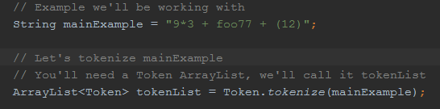  
  
The first line “String myExample” can be thought of as our input program. We take this input program and resolve it to a string. In this case, although it is a string literal, in other instances it may be a text file. This string is then sent to the static method “tokenize()” in class Token as the parameter. The result of this function is an ArrayList<Token> (and in this example) called “tokenList.” Here is the tokenize() function:  
  
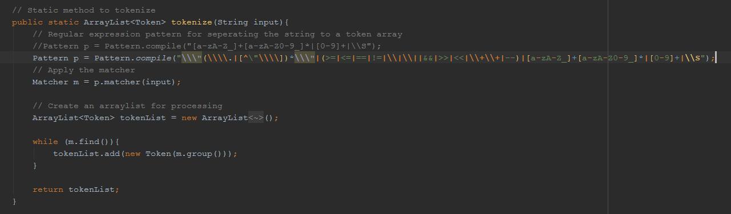

The cut off portion is already listed in the “Variable Naming Restrictions” section. We define a Regular Expression pattern to match against our input String. The result is a Matcher object, which we convert to an ArrayList using the while loop. The final output is an ArrayList<Token>, which is returned at the end of the method.

So, our original input string was “9*3 + foo77 + (12)” and our output from the Tokenizer is an ArrayList. When outputted, this is our result:

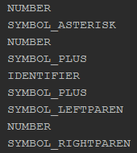

The Tokenizer was able to recognize all symbols and numbers, but the word “foo77,” since it is not in our reserved words list, is found to be an Identifier. At this stage, the Tokenizer does not know, or care, whether “foo77” is a class name, variable name, or method name. This is handled within the Parser.

**Section 5. Parser**

## Files Pertaining to the Parser

* MainParser.java – This file has some functionality to parse individual statements or tokens, as well as also functioning as a tester for the Parser.
* PClassDeclaration.java – This is one of the numerous Parser object classes used to hold parsed statements from the result of the Parser. This particular file is used to hold class declarations. It holds the name of the class (identifier), access modifier, and if the class extends another class. This object also holds an ArrayList of PDeclaration statements in the class, which essentially means all methods, variables, and any other lines of code present in the class.
* PDeclaration.java – This class is an interface for two other classes, both of which are declarations. The two classes which implement PDeclaration.java are PVariableDeclaration and PStatementFunctionDeclaration. The first of these are for variable declarations and the second is for method declarations.
* PExpression.java – This is another interface class to hold some types of expressions. This class is implemented by numerous other classes, all related to expressions or pieces of expressions.
* PExpressionAtom.java – This class is very similar to the previous entry, and actually extends it. The difference being that this class is only for single atoms of information, like values or calls to a function.
* PExpressionAtomBooleanLiteral.java – Used to store Boolean literal tokens.
* PExpressionAtomNullLiteral.java – Used to store null literal tokens.
* PExpressionAtomNumberLiteral.java – Used to store number literal tokens.
* PExpressionAtomStringLiteral.java – Used to store string literal tokens.
* PExpressionBinOp.java – This class is used to store a binary operator expression in its entirety, including both sides of the expression and the operator token.
* PExpressionOperator.java – Used to store operator tokens.
* PExpressionParserElement.java – Used to describe elements in an expression.
* PExpressionStub.java – Unused class used to document unknown objects.
* PIdentifierReference.java – This class is to store a specific type of PExpression, the reference of an internal component of an object. For example, if you want to call the “test()” method of the “temp” object, this would be stored as a PExpressionIdentifierReference object for our compiler.
* PStatement.java – Generic interface to classify certain classes as statements.
* PStatementForStatement.java – This class holds a “for” loop statement object and all parts of this statement. This includes the three parts in the header and all body statements.
* PStatementFunctionCall.java – Similar to PIdentifierReference, this class holds statements in the form of “object.method(parameters);” and includes as many parameters as necessary. Each of the parameters are stored as an ArrayList of PExpression objects.
* PStatementFunctionDeclaration.java – This class holds an entire function declaration. This includes the name of the method, the access modifier, the return type, parameters list, and entire statements list.
* PStatementIfStatement.java – This class holds an “if” statement object, including the expression in the header and all statements in the body. This includes the mandatory “else” keyword and body as well.
* PStatementPrintln.java – Used to hold any print statements.
* PStatementReturn.java – Used to hold the “return” keyword and the expression object that is to be returned.
* PStatementWhileStatement.java – This class hold a “while” loop object in its entirety. This includes the expression in the header expression and all statements in the body.
* PVariableAssignment.java – This class is used to hold the statement which gives an assignment to a certain variable name. Note this is not a variable declaration, but giving an assignment to an already declared variable.
* PVariableDeclaration.java – This class holds a variable declaration, including the name of the variable, the type, the access modifier, and an optional assignment.

## General Parsing Restrictions

The most common use of our parser, and in its final form, will only allow the user to parse entire programs. Although it contains the functionality to parse individual elements, we generally do not use this. So, given that we must parse an entire program, we must have at least one class to put our statements into. Also, because of the standard practices of the Java language, which our made up language is based upon, we cannot have any loops outside of a method. So this section will describe how to properly define classes and methods in order to pass the Parser. If a program does not pass the Parser, it has some improper syntax and will fail to compile.

In our made up language, the proper way to define a class is:

<access modifier> class <identifier> [extends <class identifier>]*  
 * = optional

Our classes require an access modifier, either public or private, then must be followed by the “class” keyword,” and then the class’s identifier. If a class is to extend another class, then the keyword “extends” must be present, followed by the name of the class it is to extend. The extending feature is optional, so if a class does not extend anything, it would simply be, for example, “public class One.”

In regards to the “static” keyword, our made up language does not support it. This means there should not be use of the static keyword in the class definition, nor in a method declaration.

In order to properly define a method, it is not so different than standard Java definitions. The way to define a class in our made up language is:

<access modifier>? <return type> <identifier> ( < comma-separated parameters >* )  
 * = optional, ? = 0 or 1

So a typical method declaration might look like “public void main(int test).”

Another restriction in our made up language relates to “if” statements. We decided to restrict “if” statements to only occur with an “else” token as well. This means and “if” statement cannot exist without the “else” token, or it will fail at the Parser. The correct syntax is listed here: “if ( <expression> ) { <statements>* } else { <statements>* }”

## Parser Output

This section discusses what the output of our Parser is, but only within the context of an entire program, similar to the previous section.

We use a token list and MainParser object to assign the output to a PProgram object, which is the final output of the Parser. This PProgram object contains an ArrayList of PClassDeclaration objects, each with a class declaration and all variables/methods for the stated class. Each PClassDeclaration object has an ArrayList of PDeclaration objects, containing either a PVariableDeclaration object or a PStatementFunctionDeclaration object. This means that inside this class declaration, there are a list of variables and methods defined within the class. Although PVariableDeclaration objects are strictly for the declaration of a variable, inside the PStatementFunctionDeclaration object, there may be any type of statement in its statement list, including “if” statements, “for” loops, “while” loops, variable assignments, etc.

Example:

In the MainParser.java file, there is code to test out the Parser. This example is from this file.  
Here we have an example input string to act as our input program:

C:\Users\NSA\Desktop\430\scr2\1.pngC:\Users\NSA\Desktop\430\scr2\2.pngC:\Users\NSA\Desktop\430\scr2\3.png

In the example, we have a main class with one variable declaration and one method declaration. Inside the method declaration, we have one parameter, one other variable declaration, and one “if” statement declaration.

Near the bottom of the class, there is some logic to somewhat peal apart the output parser object and discover which statements were resolved from the Parser:

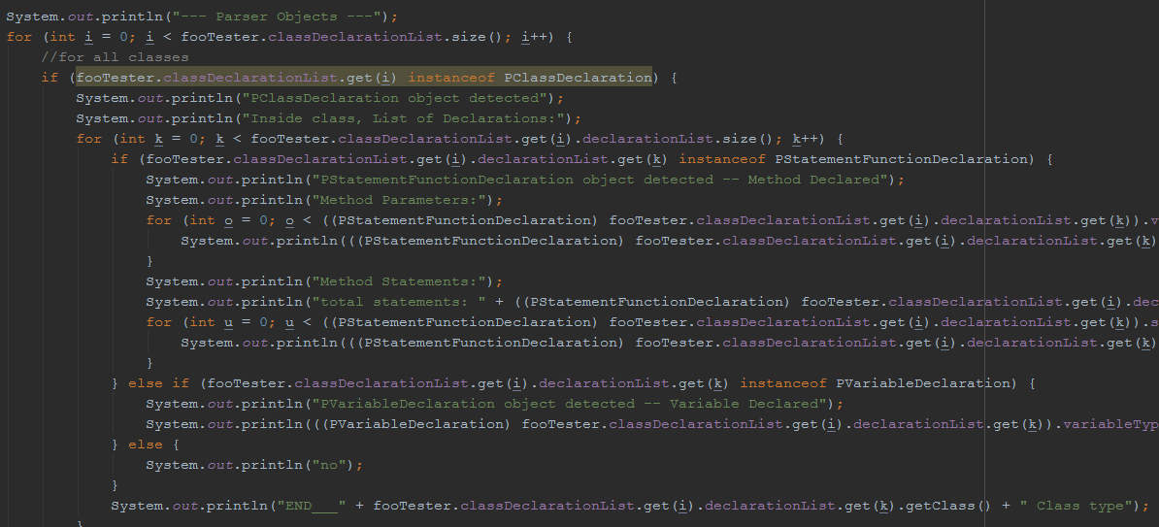

When we run the main() method of the MainParser class, we can see which objects the Parser resolved:

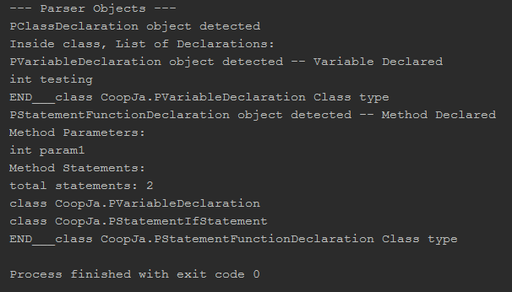

We can see the result is one class, inside of which we have one variable declaration “int testing” and a method declaration. Within the method, there is one parameter “int param1” and two total statements, a variable declaration and an “if” statement object. We can also see that the program finished with no errors, which is the result of a successful parsing.

**Section 6. Type Checker**

## Files Pertaining to the Type Checker:

(Most) PObject files: PObject.java

Type.java

TypeChecker.java

TypeCheckerException.java

## Type Checking the Program

The type checker, as its name suggest, checks the validity of the use of types in the program. Most of the responsibilities of type checking belong to the TypeChecker class, and the rest to the PObjects themselves. Depending on what kind of PObject is being checked, to get its type we either check what instance of class it is, or, more often, we use the PObject’s getType( ) method to retrieve its resulting type.

**Section 7. Code Generator**

## Files Pertaining to the Code Generator:

(Most) PObject files: PObject.java

C_CodeGenTest.java

N_CodeGenAdd.java

CodeGenException.java

J_CodeGen_ExpressionTest.java

CodeGen_UnitTests.java

## Converting Object Oriented Code and Other Designs to Function in Functional Language

The job of the Code Generator (CG) is to convert the input program in the Source Language (SL) into valid code in the Target Language (TL) so that it is executable. The CG must do its work after the parser and type-checker in order for the code to be valid in the TL. The CG takes as input the input program file. It goes through the code and, if necessary, modifies it to work in C. It turned out that the way we did code generation is through an internal method, rather than an external method, meaning it is the PObject’s responsibility to generate its own code string. In turn, PObjects have a method named generateObjectNameString( ) which returns its object’s code as a String, and this PObject calls any nested PObjects’ generateObjectNameString( ) method.

Because C is not an Object Oriented programming language, our team had to figure out ways of making Object Oriented programming viable in C. It was decided that classes would be made into structs. Class members in the SL were made into variables of the struct in the TL. Method members of a class in SL become function pointer members of their pertaining struct in TL to carry out class inheritance. The definition of these functions (pointers) lie outside the struct because they are not allowed to be defined in a C struct.

Variables that are struct members are given an identifier: structname_function.

Each struct function member has an initializing function that initializes the function with its definition.

While processing the class function declarations in the SL, we search for a main function, and we treat it differently to the other functions. We define the main function with the parameters it needs in the TL. To implement class-based inheritance, we did a lookup technique, where superclasses are looked up and its code is put in the subclasses’ struct, and any overrides of functions in the subclass are able to be done through our use of function pointers in the TL.

After the code generator process, we save this as a C file.